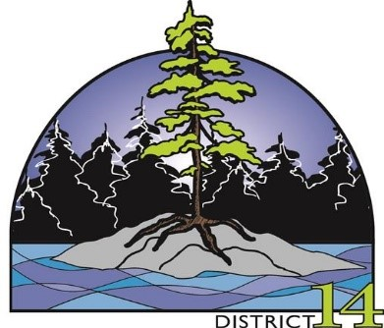
DELEGATES REGISTRATION FORM
2024 District 14 Annual General Meeting
May 3, 4 & 5th, 2024
Oliver Road Community Centre
563 Oliver Road, Thunder Bay, Ontario
and
Roots Community Garden Centre
450 Fort William Road
(Print please)
Name: _______________________________________________
Address: _____________________________________________
Phone Number: ______________________________
Dates attending: Friday, May 3rd _____
Saturday, May 4th _____
Sunday, May 5th _____
Payment due: $45.00 __________ Please make registration fee payable to your Society.
Registration deadline is April 22, 2024
Please indicate any dietary restrictions/allergies: ___________________________________

If you are the Society President or Vice-President, please indicate if you will be attending the President’s meeting on Friday afternoon, May 3rd at 4:00 pm.
Yes, I will be attending ______ No, I will be unable to attend ______
If you are assigning an alternate to take your place at this meeting, please provide name
_____________________________________
Please confirm your attendance prior to April 22, 2024 by email to:
Pat Izsak, District 14 Secretary/Treasurer (izsakp@shaw.ca)
4155 Mapleward Road, Thunder Bay, Ontario

