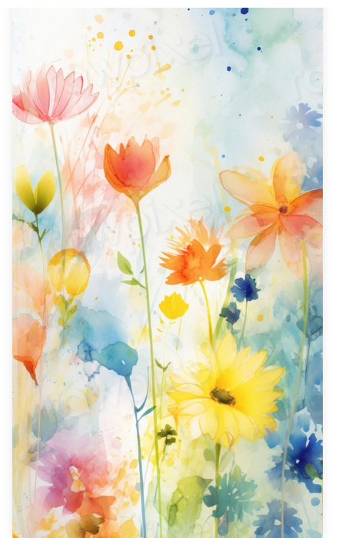
YOU ARE INVITED

TO DISTRICT 14 AGM
May 3rd, 4th, and 5th
²⁰²⁴

^{“SPRING FLING”}

